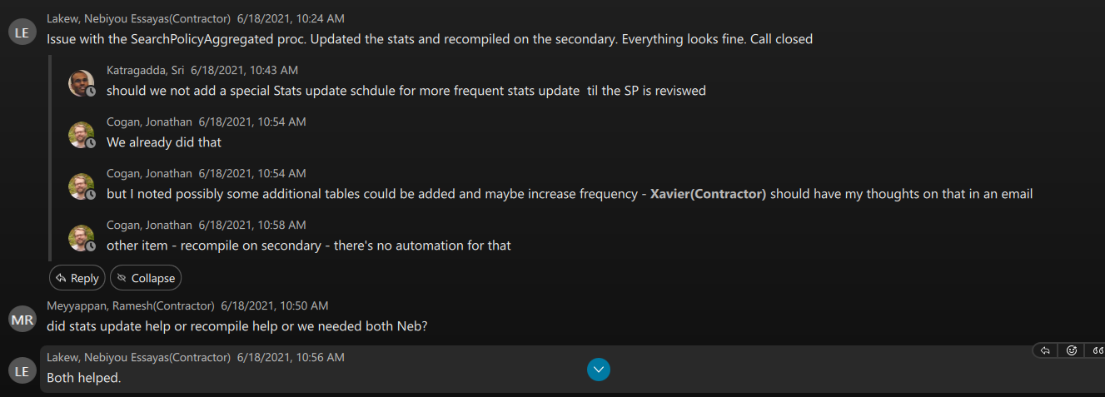
Gary
Here are execution plans for GKO_SP_BIL_SearchActivityLog

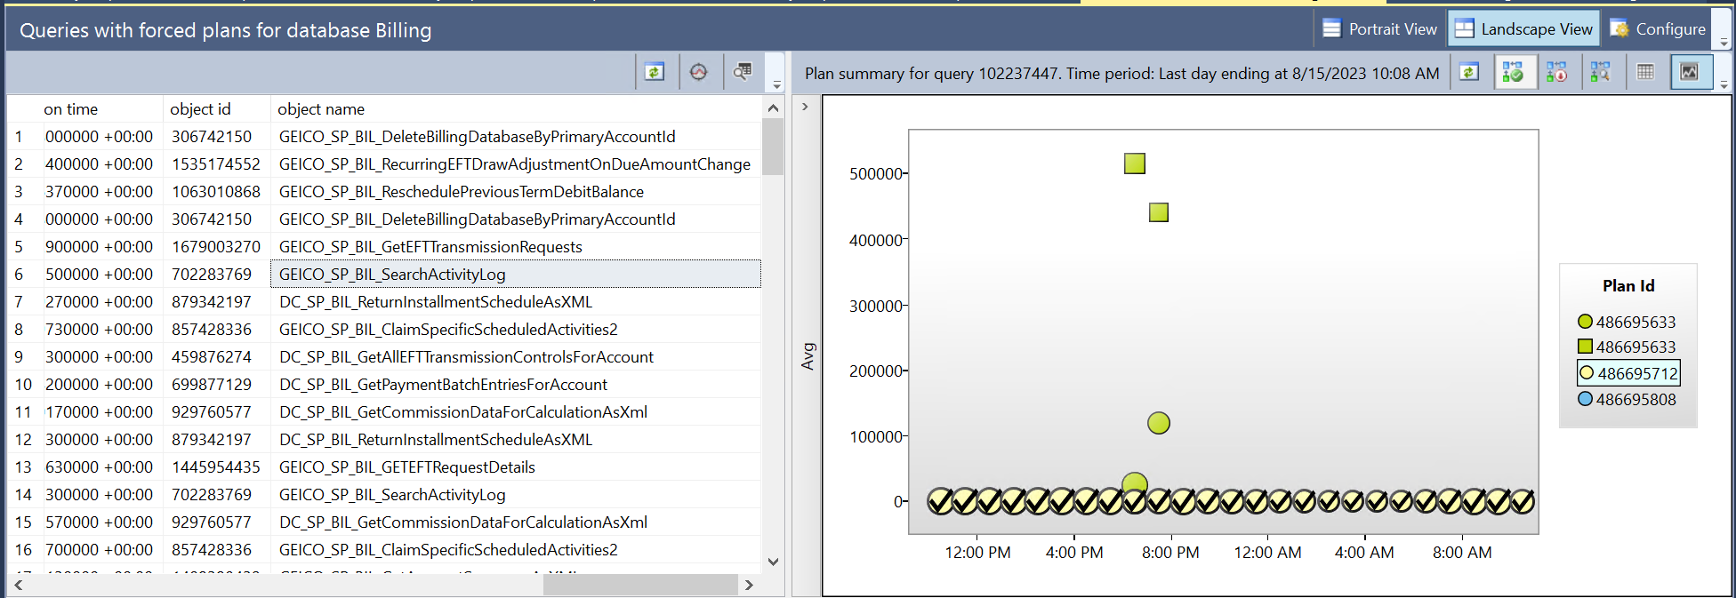

Single query in this SP has 2 parts joined by the UNION ALL statement .
First part that query data from billing database has the following difference in plans for good (yellow) and bad(green) plan

Bad plan

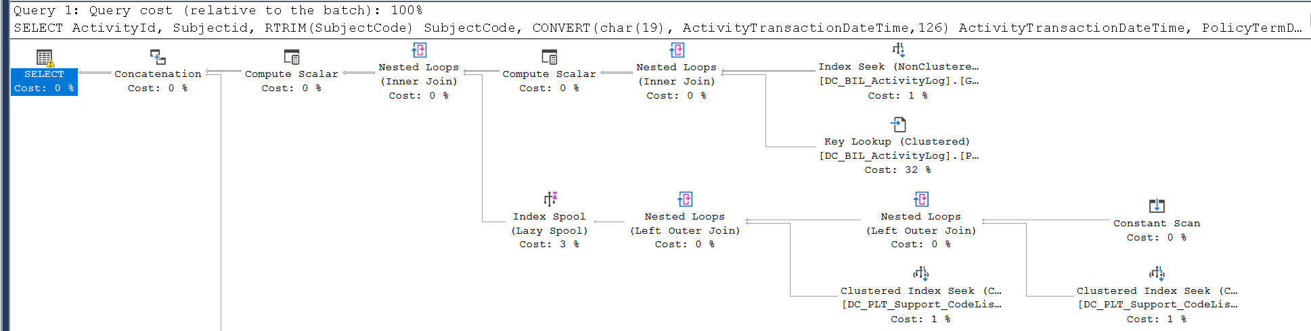
Good plan
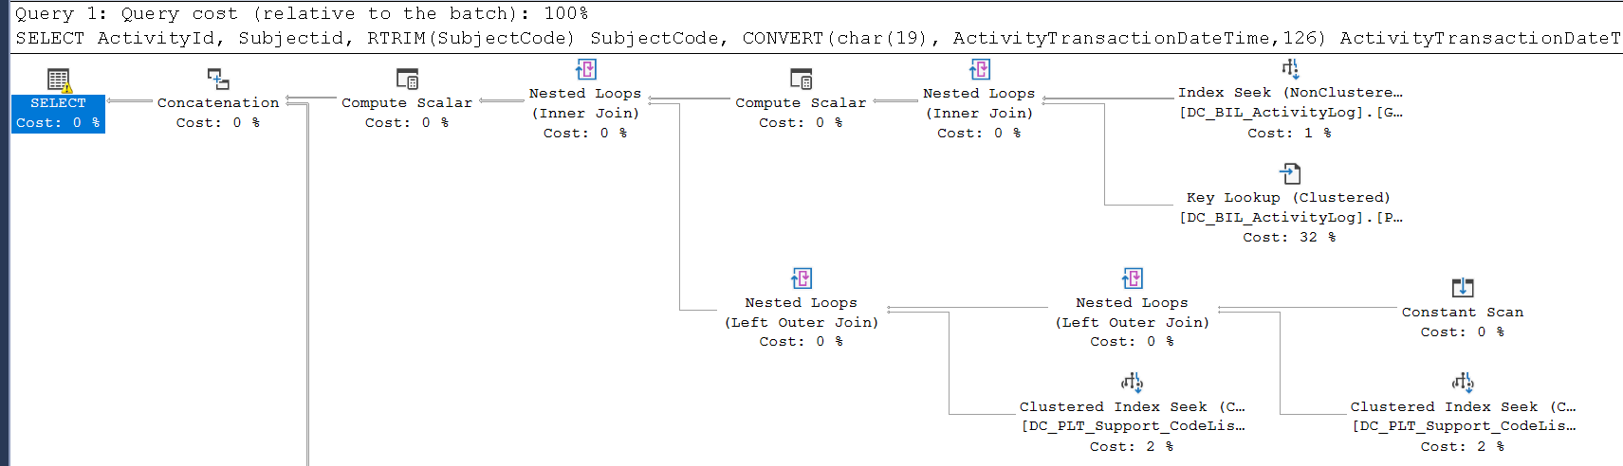

If you compare them, difference between good and bad plans is Index Spool (Lazy Spool) statement

Similarly, comparing 2 parts for the BillingActivityLog query, you see the difference – Table Spool (Lazy Spool)
Bad Plan


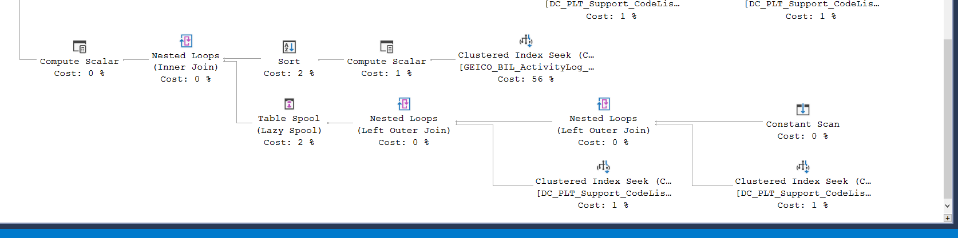
Good Plan
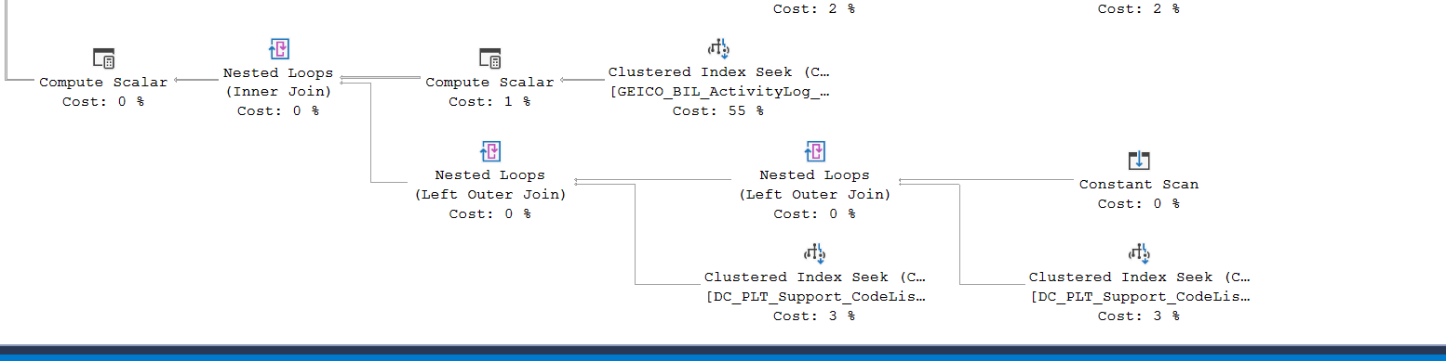

My recommendation is to utilize hint NO_PERFORMANCE_SPOOL in SP code.
We may try to do this instead of stopping Update Stats for DC_BIL_ActivityLog


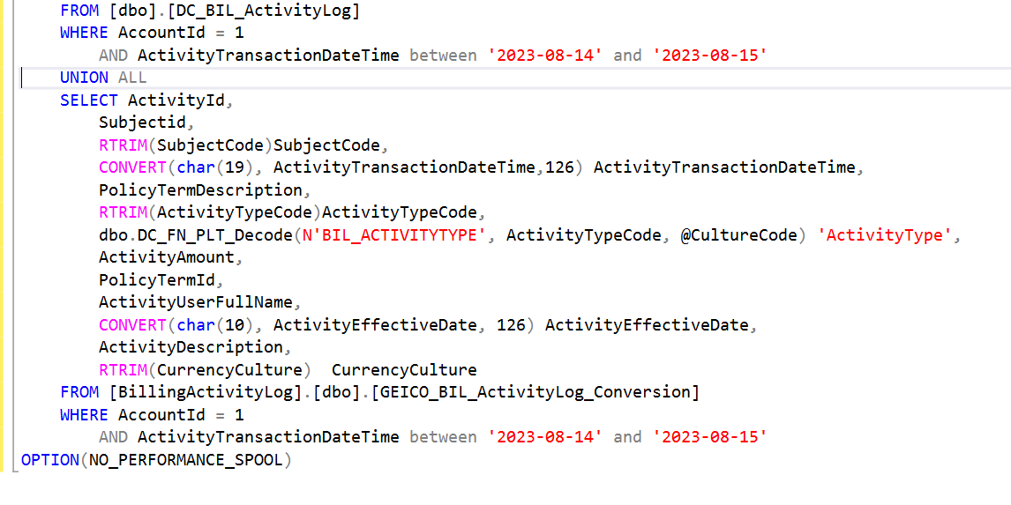

Concerned team member
Below are details that Nikhil had laid out for the test:

I’d like you provide me an window where you are not conducting any test. 1 hr is a good time for that window. I’d like to do below steps during that 1 hr window.

- Remove all the existing plans related to SP from plan cache and query store in LT1. – SQL DBA team
- Run the update stats on DC_BIL_Activitylog table in LT1 – SQL DBA team.
- Call the attached API calls through Postman when update stats running (Step 2 running ) in LT1 – PE team ( Sree or Nandeep )

We will need timeslot where a SQL DBA team member can attend as well.

Gary: As part of the test, I would recommend to run UPDATE STATISTICS commands during the load and querying targeted SP

---------
The same SP has another “monster” INSERT into the same table.
For queryID 240442 (Insert from #PolicyTerm)
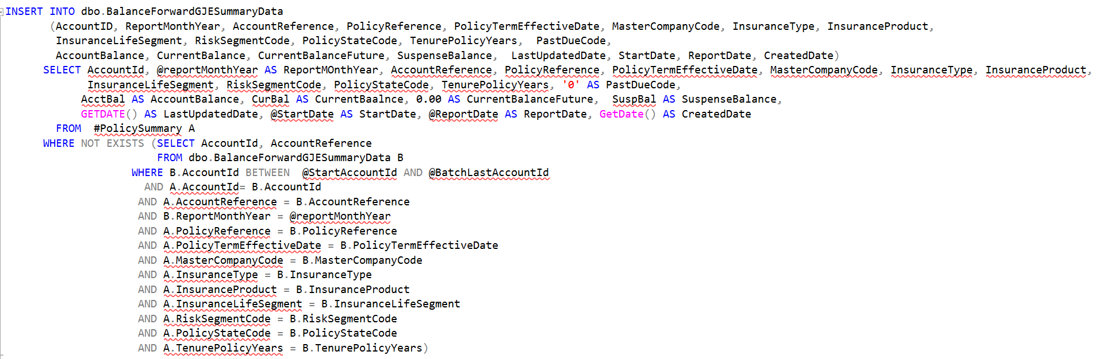

We have the following plan 74154 9attached)
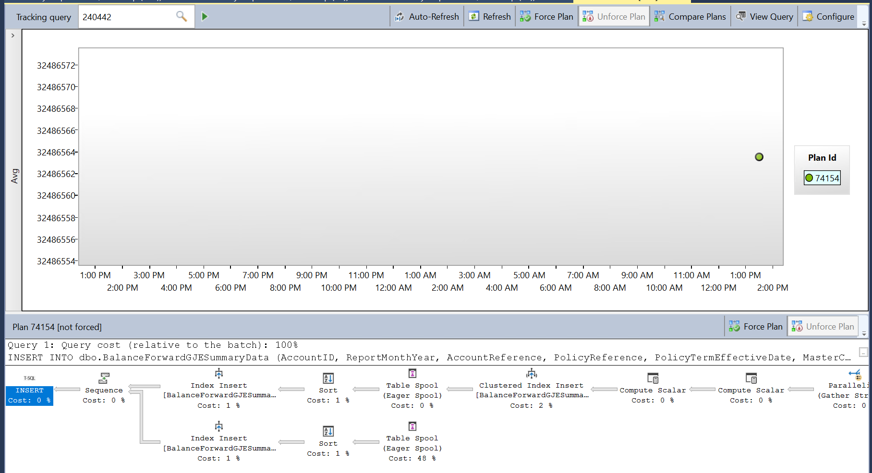

And details on Key lookups were similar to what I have shared
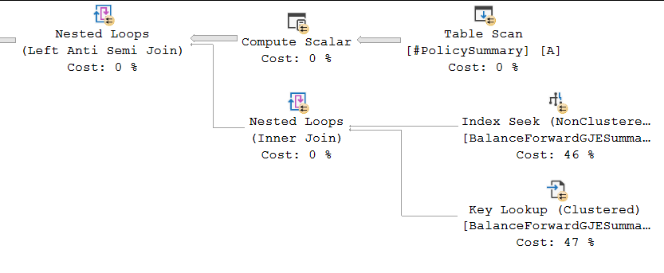

HTH
I am not analyzing if query started to perform better or worse over the time.
I see how it is executing now, and based on current process recommended changes in query (try LEFT OUTER JOIN), index modification and process (batching based on data in temp table instead of single INSERT)

Gigantic INSERT is not an efficient way to populate data.

Regards,

Gary Zaika
Yes, it is still running.

- Maybe, LEFT OUTER JOIN instead of would be faster. You need to test in lower environments.
2) try to get rid of key lookup by replacing existing index [IDX_BalanceForwardGJESummaryData_PolicyReference] ON [dbo].[BalanceForwardGJESummaryData]
3) INSERT should be break into smaller batches

FROM #PolicySummary A
WHERE NOT EXISTS (SELECT AccountId, AccountReference
FROM dbo.BalanceForwardGJESummaryData B
WHERE B.AccountId BETWEEN @StartAccountId AND @BatchLastAccountId
AND A.AccountId= B.AccountId
AND A.AccountReference = B.AccountReference
AND B.ReportMonthYear = @reportMonthYear
AND A.PolicyReference = B.PolicyReference
AND A.PolicyTermEffectiveDate = B.PolicyTermEffectiveDate
AND A.MasterCompanyCode = B.MasterCompanyCode
AND A.InsuranceType = B.InsuranceType
AND A.InsuranceProduct = B.InsuranceProduct
AND A.InsuranceLifeSegment = B.InsuranceLifeSegment
AND A.RiskSegmentCode = B.RiskSegmentCode
AND A.PolicyStateCode = B.PolicyStateCode
AND A.TenurePolicyYears = B.TenurePolicyYears)
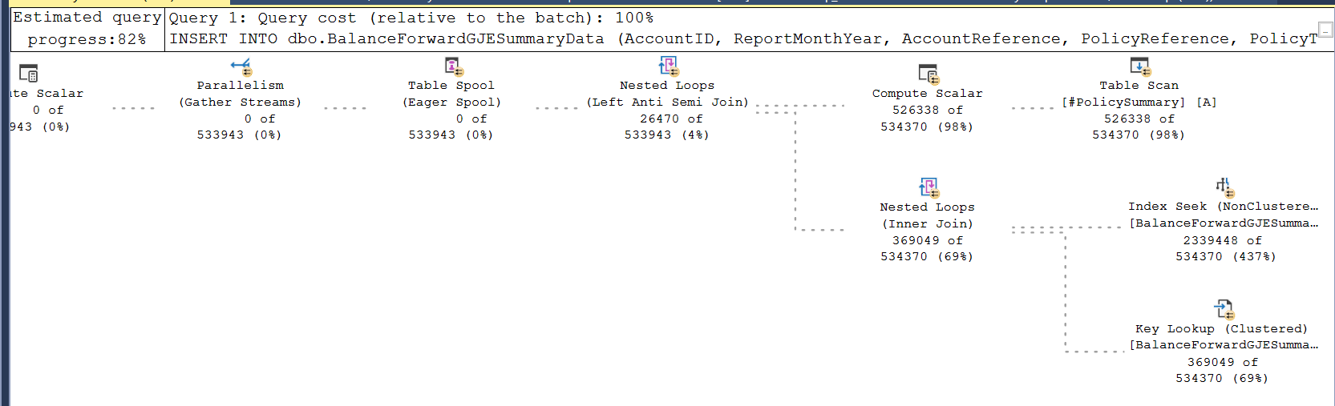

Here are some details from QS (Execution Plan attached)
For QuerIDy 240064 (below)
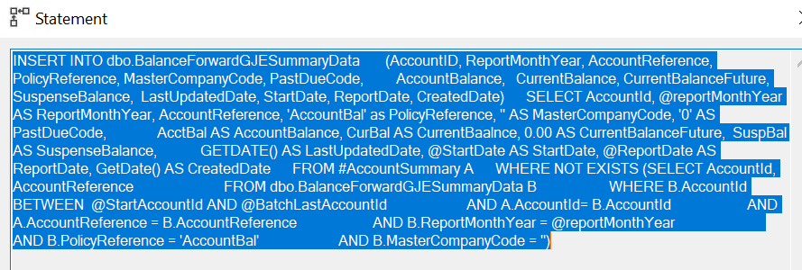

Here is execution plan 73844 with missing index
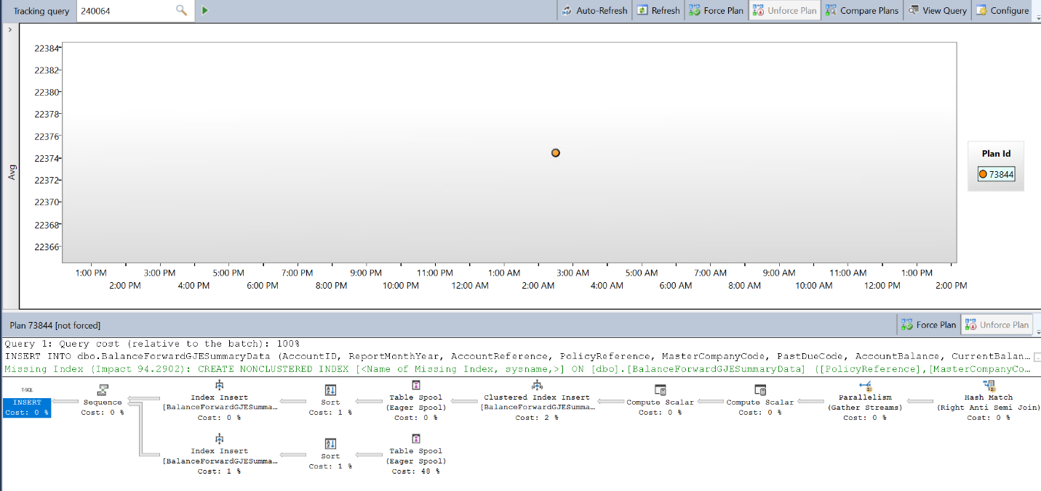

Missing Index Details
/*
Missing Index Details from SQLQuery1.sql - GZEBALBCSPD1SQ1\SQL1.BCS ())
The Query Processor estimates that implementing the following index could improve the query cost by 94.2902%.
*/

/*
USE [BCS]
GO
CREATE NONCLUSTERED INDEX [<Name of Missing Index, sysname,>]
ON [dbo].[BalanceForwardGJESummaryData] ([PolicyReference],[MasterCompanyCode],[ReportMonthYear],[AccountID])

GO
*/

------------
Yesterday at 3pm, a schedule process between Commercial Premium Reporting and Workday failed due to a SQL Timeout.

The data volume yesterday was miniscule – only 606 records.

I consulted with DevOps and they did identify high CPU usage from 2am to 4pm yesterday. We are assuming this is a backup.

Please confirm that or let us know what was happening at 3pm yesterday that would have caused this issue.

The Commercial Premium to Workday process has become a high visibility item as of late, and we need to be able to account for any unexpected conditions such as this.

If we need to open a support ticket for this – I can take care of that – just let me know where it needs to be done.

Thank you.

Gary’s answer
There is nothing unusual if you experience bad performance every Sun.
SQL Backup job for PREM database runs about 15 hrs starting at 1:30am.

Due to the size of PREM database, backup utilizes 58 threads to run backup.
Your server has 64 cores from which 4 cores are not available for SQL Server operation due to the configured affinity mask. You have only 2 cores to process everything else.

My recommendation is to change affinity mask and give 2 additional cores to SQL Server (62 instead of current 60).
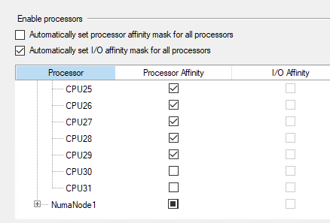

Also, Update Stats job runs daily according to this schedule.
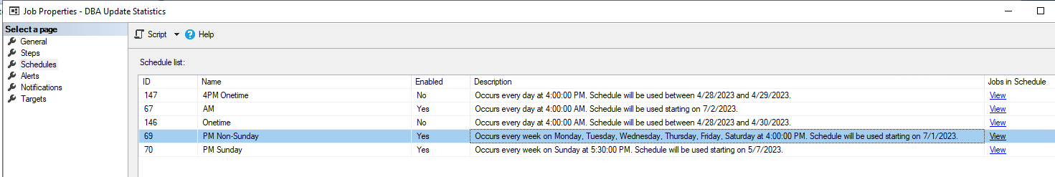

My recommendations are
- Disable 4AM schedule because it is not being used anyway because Update stats execution that starts at 4pm still running at 4am next day.
- Change schedule of Update Stats job on Sat since it overlaps with Full Backup. Start running it on Sat at 11am
----------
This morning about 1130am we had a NOC call about the perf issues on BILDUK UAT- attached, there was a BILRPT job that was running . We killed it and disabled it.
BILDUK server in UAT is 1 node with 64core- 500GB ram and Billing DB is 20TB W/5TB used. We have been running a DB shrink to recover the free space and that will run for a while. Eventually we will reduce the size to 16/20 core after DB size is brought under control.

Do you have timing/dates when UT1 had VM downgrades, particularly if this is across api’s.

There was a SKU downgrade for BILADC-UT1 sometime in May. On June the 23rd we reduced from 8 to 4 VMs, which would be few days after these failures started. I would also add that while it’s possible there’s some kind hardware metric bottleneck, to me it doesn’t seem like it’s CPU and I haven’t found a smoking gun anywhere else yet.

Gary
Shrinking is absolutely impacting all activity.

I would recommend to upgrade back to Premium storage temporary. It would make Shrink run faster.
Otherwise, it will be very painful process for both SQL DBA and Application Team.

Running 16-20TB database on Standard storage is against Microsoft recommendations
“another type of Azure disk storage is Standard SSD, this also gives a good performance like premium SSDs if you are running small to medium applications with low IOPS. This is a cost-effective storage option if you need consistent performance lower than premium disks. You will have a severe performance impact if you consider this disk for your medium to large applications. Consider premium ssds for such applications.”
……….

On cost optimization
Gary
Did we consider 2 other possible options that would benefit Gko financially much more than SKU downgrade:

- Consolidating small databases in a single instance?
- Installing 2nd SQL Server instance on existing VMs

----
On the size of VM
Gary said to Marshal,

CPU utilization is not only factor that should be considered.
Memory is much more important for SQL Server operations.
And utilizing in Prod VMs with just 2 cores is risky.

Using only CPU in your recommendations is absolutely wrong approach.
Also, size reduction reduces the limit on number of drives supported by VM
For example, D2s_v3 supports only 4 disks which is less than our standard configuration.
You would kill the Prod with such SKU downgrade.

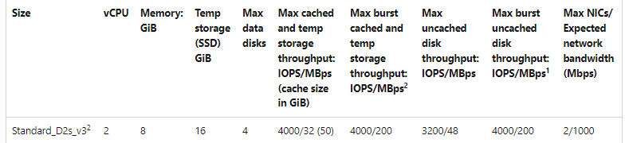

Can you first discuss the recommendations with SQL DBA before proposing to FinOps and Application Team?

Regards,

---------
Below two stored procedures are getting aborted frequently on GenApi SQL database. When execution times of Stored procedure crosses 30 seconds, it aborts.

- exec [prGetPrefillFailedTransactions] @GenericTransactionRecordCount=1000
- exec SP_GetFICOTransactionByHistoryId @HashKey=N'SCORING-416551T5819007-983332425',@ApplicationName=N'VHS2',@HistoryId=N'983332425' (parameters are different each time)

Remediation: Increase the time out value on the application to 60 seconds. Have the developers take a look at this stored proc. Size of the database is 28TH. This definitely calls for archival/purging of data.

Also, attached is a list of missing indexes on GENSQL db. They need to be created.

During full backups (last for 7+ hours), CPU utilization is 100%. Please see the last screenshot. This does warrant for a SKU size increase. Let me know if you have any questions.
-------------------------

Girum
As of my analysis this is top execution count query ..

select setId ,LEFT(policyNumber, LEN(policyNumber) - CHARINDEX('_', REVERSE(policyNumber))) as policyNumber,case when CHARINDEX('_', policyNumber) = 0 then ''
else RIGHT(policyNumber, LEN(policyNumber) - CHARINDEX('_', policyNumber)) end as HistoryID ,policyNumber as full_policy_number,row_number() over (partition by setid, policynumber,coveragecode
order by vehicleUnitNumber) as vehicleUnitNumber ,vehicleUnitNumber as vehicle_key,coverageCode ,PSLPcoveragePremiumAmount as Capped_Premium,
cast(round(PSLPcoveragePremiumAmount/case when PSLAPcappingFactor = 0 then 1 else PSLAPcappingFactor end,2) as Decimal(9,2))as Uncapped_Prem_Calc,PSLAPtruePremiumRenewalAmount
as Uncapped_Prem_Maybe,PSLAPcappingFactor,PSLPvehicleExpenseFee,cast(round(PSLPvehicleExpenseFee/case when PSLAPcappingFactor = 0 then 1 else PSLAPcappingFactor
end,2) as Decimal(9,2)) as Uncapped_Vehicle_Expense,PSLPpolicyExpenseFee ,cast(round(PSLPpolicyExpenseFee/case when PSLAPcappingFactor = 0 then 1 else PSLAPcappingFactor
end,2) as Decimal(9,2)) as Uncapped_Policy_Expense,PSLPvehicleCovRateGenCode as RATEGEN from [dbo].[PURERESULT_CoverageSetResponse] as a where setId = 11706 and subsetid = 0
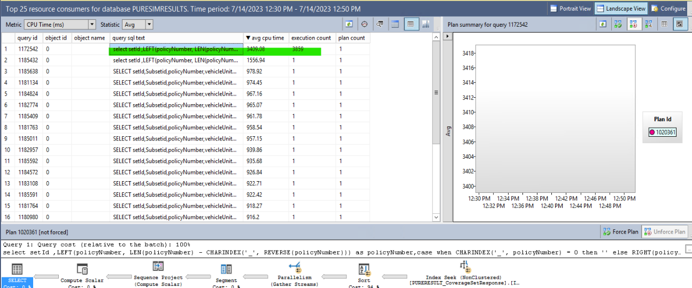

This the Adhoc query has high CPU usage and I have seen multiple ADHoc query on this server have number of plans for a single query.

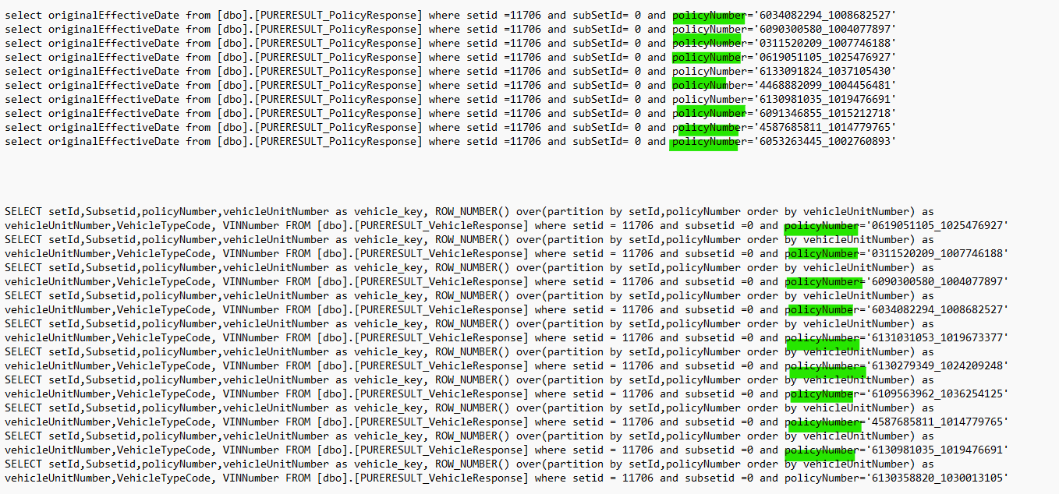

Thank you

Sri comes in
TY Girum, Jason and Kevin are reviewing the Plan. So far the plan is costly and gets executed a lot of times this is killing it & combined with this Policy number varchar( max) that is impacting the performance. The table has a lot of columns that are varchar( max) a poor design of the program. We are getting memory grant pending issues.

They are going work on re writing this IF possible , we recommend the app team to redesign this process. This is not scalable code

Can you pre calculate this data and save it for each combination?

Jason comes in
This is 99% of the cost - ROW_NUMBER() OVER (PARTITION BY setid, policynumber, coveragecode ORDER BY vehicleUnitNumber) AS vehicleUnitNumber

The policynumber and coveragecode columns are defined as varchar(max). Policynumber has a max length of 21 chars and coveragecode has only a max length of 4 chars. Just removing these 2 columns from the ROW_NUMBER function improves the performance of the function by 2x (half the cost and half the memory grant). Converting the two to better lengths helps but not as much. Ideally, the table design would be updated such that appropriate varchar lengths are used for any field that has the MAX definition. Using appropriate data types and sizes would also allow us to implement better indexes to support queries such as this.

As Sri mentioned, this problem becomes far worse when multiple queries / batches are hitting this table at the same time. Due to the cost, memory and IO, this query takes 1-3 seconds depending on parameters used. If there are several queries running at the same time, then that response time dwindles to 20 seconds to return the same data set. The table mentioned is [dbo].[PURERESULT_CoverageSetResponse]. I have been using the values setId = 11706 AND subsetid = 0 for these timings and testing. Different values will run faster/slower depending on quantity of records in the result set.

To make this scalable and consistent in run times, we need to start by addressing the design issues with the table.

